Week 14: White Rose Home Learning

For each lesson this week, except Friday, you will need to watch the relevant video, and stop it occasionally, to answer questions from the activity worksheet. You can now access each day’s video from the link provided. To access the daily worksheet simply click on the appropriate file on our school website.

- Get ready: Click open today’s activity worksheet – for example Monday Maths. If you are unable to print off the worksheet, simply write the answers in your book.
- Get set: Click on the video link provided and watch until it tells you to stop watching.
- Go: Answer the questions from the worksheet. You can write the answers into your home learning book; no need to print anything out. Then continue watching the video.
- Once finished, check your answers by clicking the appropriate file, for example Monday Maths Answers.
- Daily extensions are provided on the next few pages.

Monday - Lesson 1: Subtracting decimals with the same number of decimal places
Click here to watch the video: https://vimeo.com/430338565

Tuesday - Lesson 2: Subtracting decimals with different number of decimal places
Click here to watch the video: https://vimeo.com/430338659

Wednesday - Lesson 3: Multiplying decimals by 10, 100, and 1000
Click here to watch the video: https://vimeo.com/430338787

Thursday - Lesson 4: Divide decimals by 10, 100 and 1000
Click here to watch the video: https://vimeo.com/430338904

Friday – Arithmetic Paper (Maths Friday).

Daily extensions

Green Monday
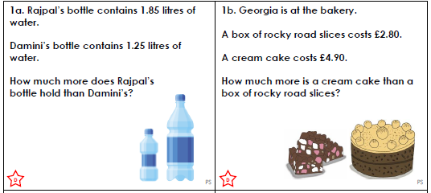
Green Tuesday
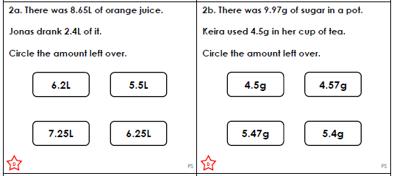
Green Wednesday
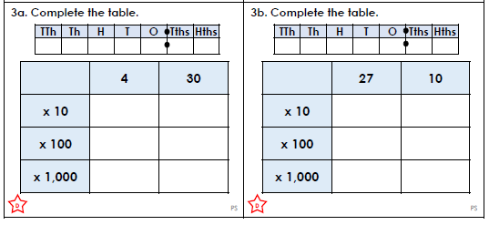

Green Thursday
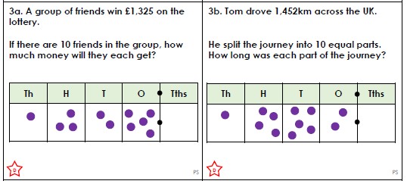

Pink Monday

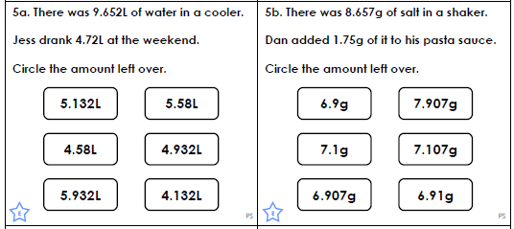
Pink Tuesday

Pink Wednesday
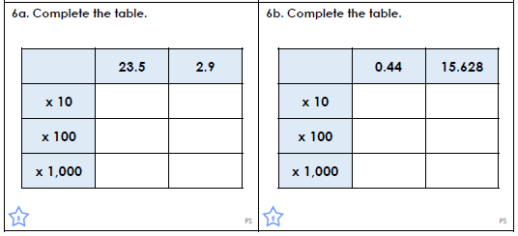

Pink Thursday


Purple Monday

Purple Tuesday
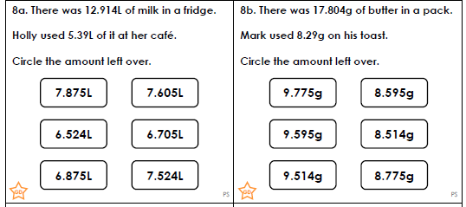
Purple Wednesday
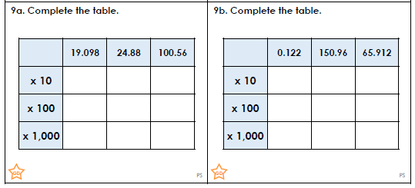
Purple Thursday


