Home Learning Task RE

 | Learning Question | Resources | Tasks
EYFS | Why do Christians put a cross in an Easter Garden? | 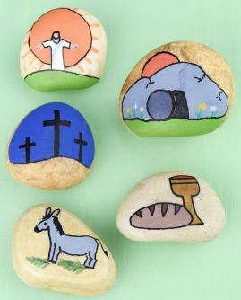  https://www.bbc.co.uk/cbeebies/stories/lets-celebrate-easterperformance  https://www.bbc.co.uk/cbeebies/watch/lets-celebrate-easter | Give the children simple images from the Easter story to take home to reorder and retell the story. Can they either match the images with key words or write simple sentences underneath describing what is happening.
Year 1 | Why does Easter matter to Christians? | https://www.youtube.com/watch?v=bkNTU_Vv5Ew – Beginners Bible Easter Story  https://www.youtube.com/watch?v=Wnbo2AmS3OI Religions of the world – Easter story  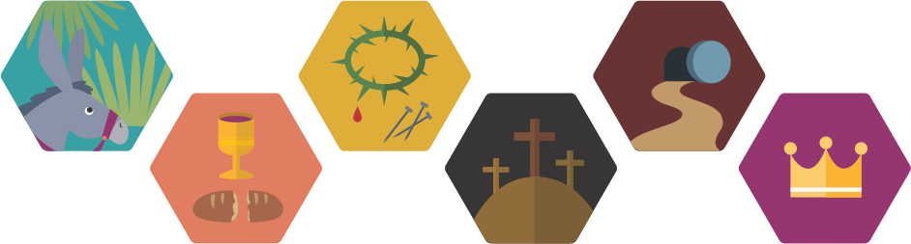 | Can you use these images to retell the Easter story?  Why does Easter matter to Christians?
Year 2 | What symbols do Christians use to remember Easter? | 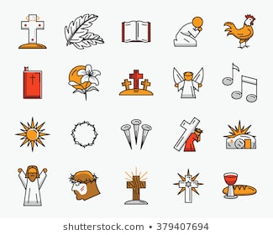 | Discuss symbols related to Easter. How do these help Christians remember the events of Holy week?  Share this Easter acrostic poem with pupils.  Easter is a time when Christians think about Jesus.  A time when Jesus died on the cross.  Sad parts of the story are remembered at Easter.  There are such happy parts too!  Especially when Jesus rose from the dead.  Rejoicing happens at Easter.  Discuss features of the poem, including each line starting with a given letter from the word, lines all relating to the topic, and the fact that no rhyming is necessary.  Encourage them to have a go at writing their own poem about Easter.
Year 3/4 | Why do Christians call the day Jesus died good? | https://www.youtube.com/watch?v=MK2o-mhBfuc&list=PLcvEcrsF_9zLNjB-h9xjVlhgG8f0fjk-9&index=3 My life, my religion – Easter  https://request.org.uk/restart/2017/06/05/bible-quest-holy-week/ The Easter story  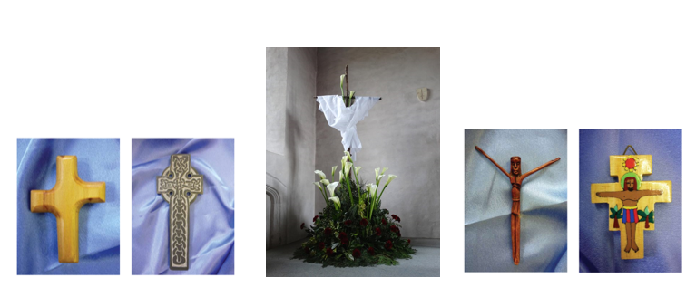 | You have been asked to create a display for your local church either to go in a window that can be seen from outside the church, or another form of presentation that can go on the church website, showing the importance of either Palm Sunday, Good Friday or Easter Sunday. (It could be a power point, poster or piece of artwork)  Can you include a suitable cross with an explanation about what this reminds Christians of.  A recount of the key part of the Eater story linked to your display.  You might title each of the displays:  Why is Palm Sunday so important to Christians?  Why do Christians call the day Jesus died Good Friday?  What do Christians believe happened on Easter Sunday?
Year 5 | What did Jesus do to save human beings? |  | The command to ‘Love your neighbour as you love yourself’ will involve some sacrifice.  What does it mean to sacrifice something? (the act of giving up something that you want to keep especially in order to get or do something else or to help someone.)  Ask pupils to draft a short charter for the school, explain how far the idea of sacrifice is good and necessary for making  the world a better place.  They should make links with Christian ideas and Jesus’ teachings. It is perfectly fine for them to say that sacrifice is not good, but they must offer good reasons and alternatives that will make the world a better place!
Year 6 | What difference does the resurrection make to Christians? | 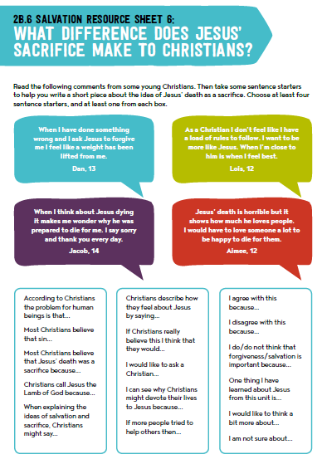 | Read the following comments from some young Christians.  Then take some sentence starters to help you write a short piece about the idea of Jesus’ death as a sacrifice. Choose at least four sentence starters, and at least one from each box.

