The Piano Day 2

Watch the film again, possibly twice.

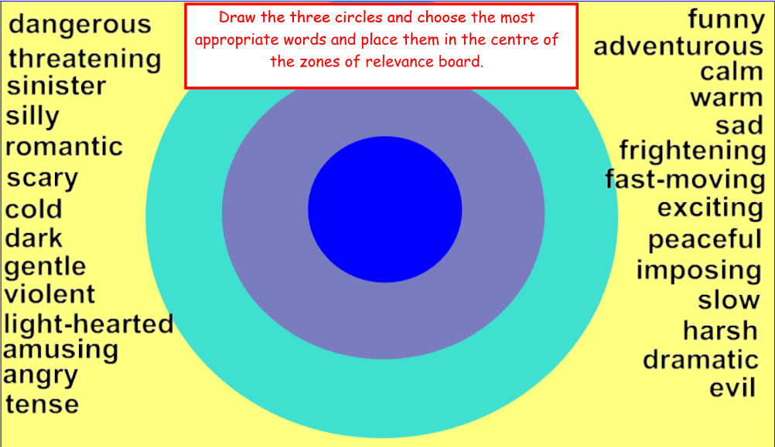

After you have selected the right words, please do the next activity. Write at least one paragraph explaining the choice of words you placed in or near the centre – referring back to what you saw in the film.



