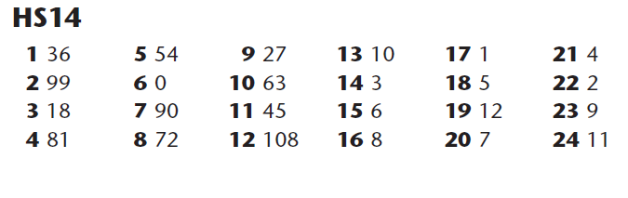
9 x table answers

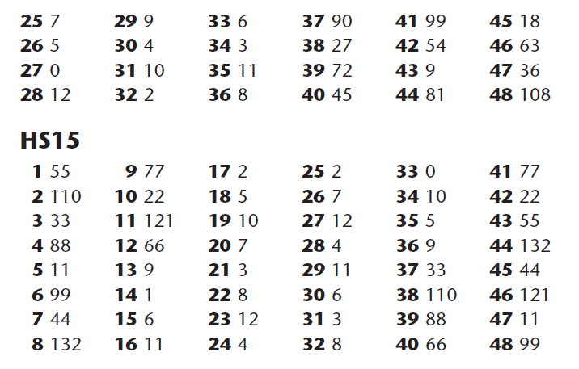
11 x table answers

