EYFS | Download and Read the Easter journal  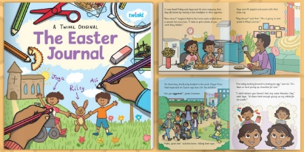  https://www.twinkl.co.uk/resource/the-easter-journal-ebook-t-or-1135 | Empty Tomb  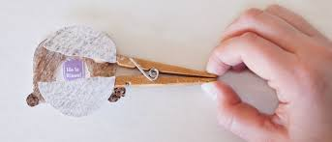  https://homefrontmag.com/empty-tombs-easter-craft/ | 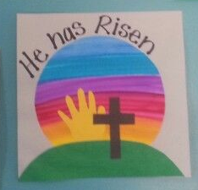  To recreate this picture. Draw round you hand to create the sun. Paint a rainbow on a separate piece of paper, when it has dry cut it out in a circle. Stick then to a piece of paper and paint on a hill and a cross.
KS1 | Picture Frames  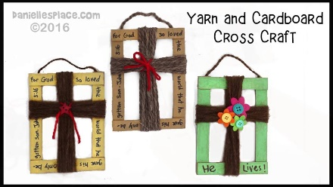  https://www.youtube.com/watch?v=4YwRf0IUi58 | 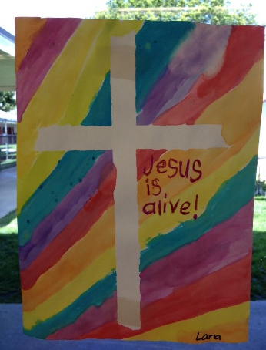  Place masking tape in the shape of a cross then paint over the top allow to dry and then remove the tape and decorate. | 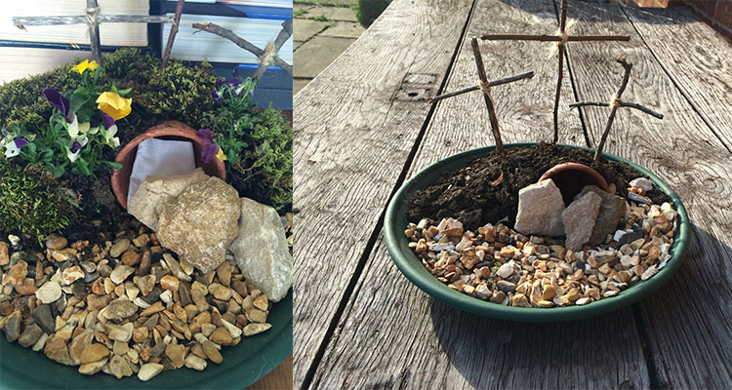  Can you use things you find in the garden to recreate an Easter garden. How does this help Christians remember Easter?
KS2 | 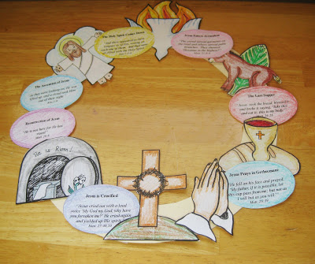  Easter Wreath- Download and pint template from this website or you can draw your own based on the picture. http://www.weelittlemiracles.com/2012/04/make-easter-story-wreath-free.html | 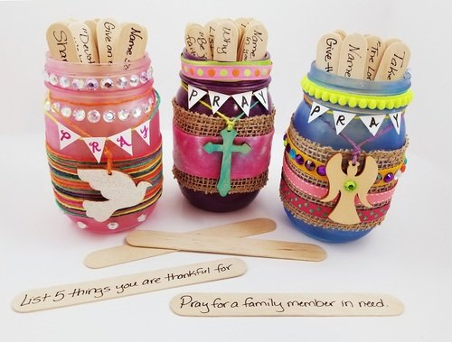  Decorate an old jar and then write on craft sticks things a Christian may pray for or reflect upon and place them in the jar. E.g. name a positive event that happened to you this year.  Give an example of a blessing God has given you.  Pray for a family member in need. |   Print out and colour this mindfulness colouring sheet,  Use three colours that Christians associate with Easter and explain why you have chosen them.

