Tuesday Activity: Roman Numerals
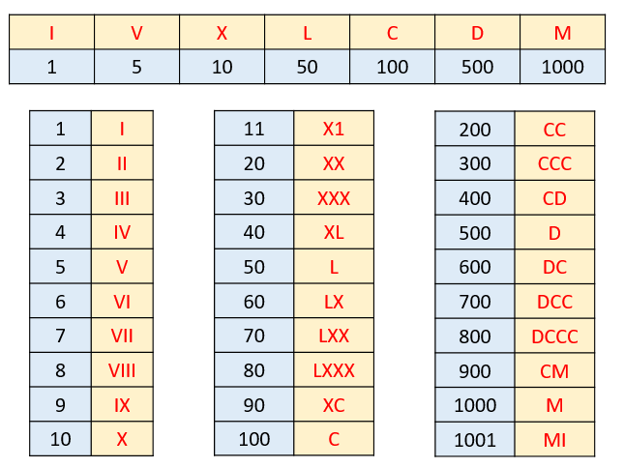
Card Game: Matching pairs
Create your own playing cards to play pairs. Simply cut out 74 small rectangles, from pieces of scrap paper or card. Write on each card, either one of the digits or roman numerals, until you have written down all 37 matching pairs. Now mix them up and lay them face down in front of you. Set a timer and see how long it takes for you to match all 37 sets. Once you have completed the challenge, see if you can beat your time on the next round. Have fun!

- Each diagram shows a number in digits, words and roman numerals. Please draw and complete each diagram.



- Draw and complete the following:

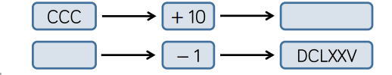

- How many calculations (multiply, divide, add) using roman numerals, can you write to get the same total?
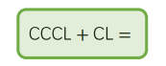
- Copy and complete:
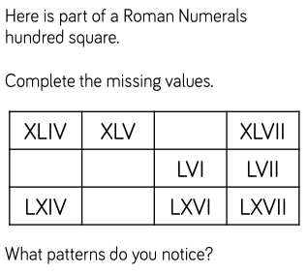

- Copy and add the symbol < > or = to the following statement:


