Friday Activity: Counting in Powers of 10 and Ordering

When answering the questions, please use key maths vocabulary:
place value | column | addition | subtraction
tens | hundreds | thousands | ten thousands
hundred thousand | negative numbers | positive numbers | sequence

- Copy and complete the sequence and rule:
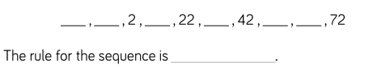

- Spot the mistakes in each sequence, then write each sequence correctly.

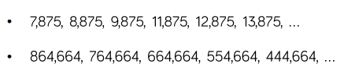

- Is Amir correct? Explain how you know.

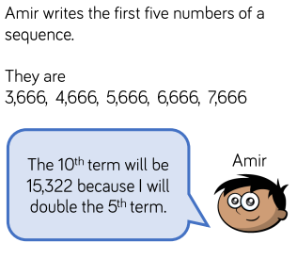
- Who has made a mistake? Explain how you know.
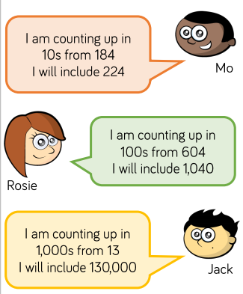

- Put the numbers in order of size:

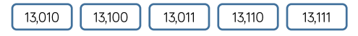

- Copy the number line and estimate the values of A, B and C:
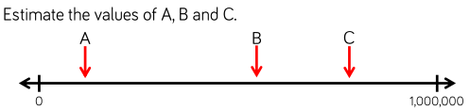

- Read the table below. Copy and complete the statements:
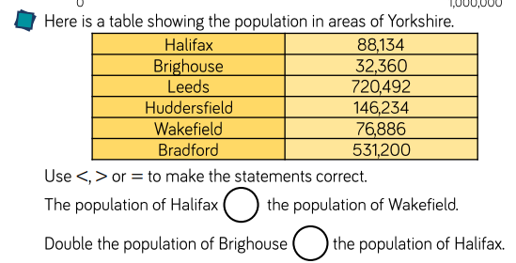

- What could the number be? List the possibilities.

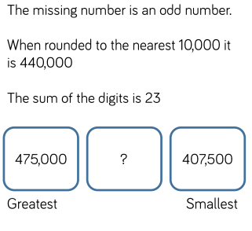

- Which card did each child have?
