Monday

Count the number of objects in tens then ones. Show it in jumps on the number line. Write the number.



Count in tens then count on in ones!

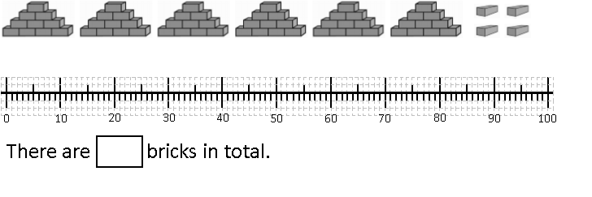

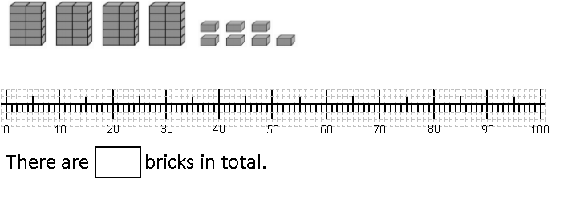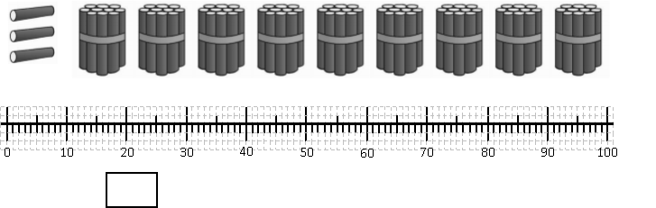

 Tuesday



|  |  |
| --- | --- |
|  |  |
| 7 | 2 |

|  |  |
| --- | --- |
| Tens | Ones |
| 7 | 2 |

|  |  |
| --- | --- |
|  |  |
|  |  |



 DD



|  |  |
| --- | --- |
| Tens | Ones |
|  |  |





 Tuesday

|  |  |
| --- | --- |
|  |  |
|  |  |







|  |  |
| --- | --- |
| Tens | Ones |
|  |  |





Can you draw your own representations?

32

24

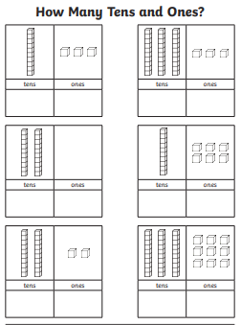Wednesday

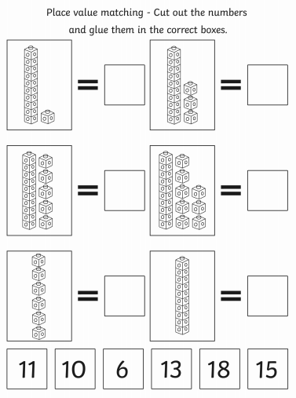Thursday