Question 2: **What important objects and place may Hindus have in their homes? Why are these important?**

Ask the children to think about the place that is most special to them. Why is it special? What makes it special?

Look at this picture below on p. 4 – What do you think it is? Where might it be found? Why might they have one of these? Watch the video clip bellow.

<http://www.bbc.co.uk/learningzone/clips/puja/4799.html>

Hindu families go to the shrine to focus their energy and concentration when praying as a family. The Punjab tray is an important part of the shrine. Use the pdf document ***Places-of-Worship-Mandir*** to go through the different items on the tray. Why is each item important? Use the worksheet if you are in year 1,2. Years 3,4,5 and 6 design a shrine for a Hindu home. Make sure you include all the key elements of a Punjab tray. Resources:

<https://www.twinkl.co.uk/resource/tp-re-335-re-religion-and-rituals-puja-year-1-lesson-pack-3>

This investigation enables pupils to learn about key aspects of Hindu belief and worship. What we call ‘Hinduism’ is the diverse way of life, spiritual practices and beliefs of the Indian people. We are focussing on British Hindus, and there is great diversity in British Hinduism as well as the original Indian Hinduism. Hinduism is more appropriately called ‘Sanatana Dharma’; eternal truth. We will find out some key Hindu beliefs, and how these are expressed in thoughts and actions. We will also think about being a Hindu in Britain.

Question 1: **How do Hindus show their faith?**

Activity: On the sheet 2 below draw or write about four things that are important to you. Then watch this clip of Simran and her brother Vraj who are British Hindus (link below).

Once you have watched the video, use the same sheet to identify Simran or Vraj’s important things, religion, hobbies, likes and dislikes, important aspects to their life.

Resources:

www.bbc.co.uk/programmes/p02n5xj7 N



**Hinduism**

**What does it mean to be a Hindu in Britain today?**

Question 3: **How are Hindu festivals celebrated?**

# Activity: Watch and read pdf documents about Holi and Diwali. Why are these important festival for Hindus? Can you create a picture to show key events for each festival? Label your picture and include explanations for parts of the pictures.

**Holi**

<https://www.bbc.co.uk/teach/class-clips-video/holi-the-spring-festival/zkkygwx>

Twinkle PowerPoint- Holi

<https://www.twinkl.co.uk/resource/lt-t-967-holi-festival-information-powerpoint>

**Diwali**

<https://www.bbc.co.uk/bitesize/clips/zxjxn39>

<https://www.bbc.co.uk/bitesize/topics/zh86n39/articles/zjpp92p>

Question 4: **Where is a special place for Hindu people?**

Activity: Watch the video and read the pdf about going to the Mandir to worship. Make a list of things that happen.

Resources:

<https://www.twinkl.co.uk/resource/t2-r-163-places-of-worship-hindu-mandirs-ks2-powerpoint>

<http://www.bbc.co.uk/learningzone/clips/worship-in-a-hindu-shrine/3619.html>

<https://www.youtube.com/watch?v=o-s0mN5P8jo>

Additional sources of information to help with research.

<https://www.bbc.co.uk/bitesize/topics/zh86n39>

<https://www.twinkl.co.uk/search?term=hinduism>

**Final Task:** Using the information you have learnt about Hinduism, create a poster or fact file to teach your friends all about the Hindu Faith.

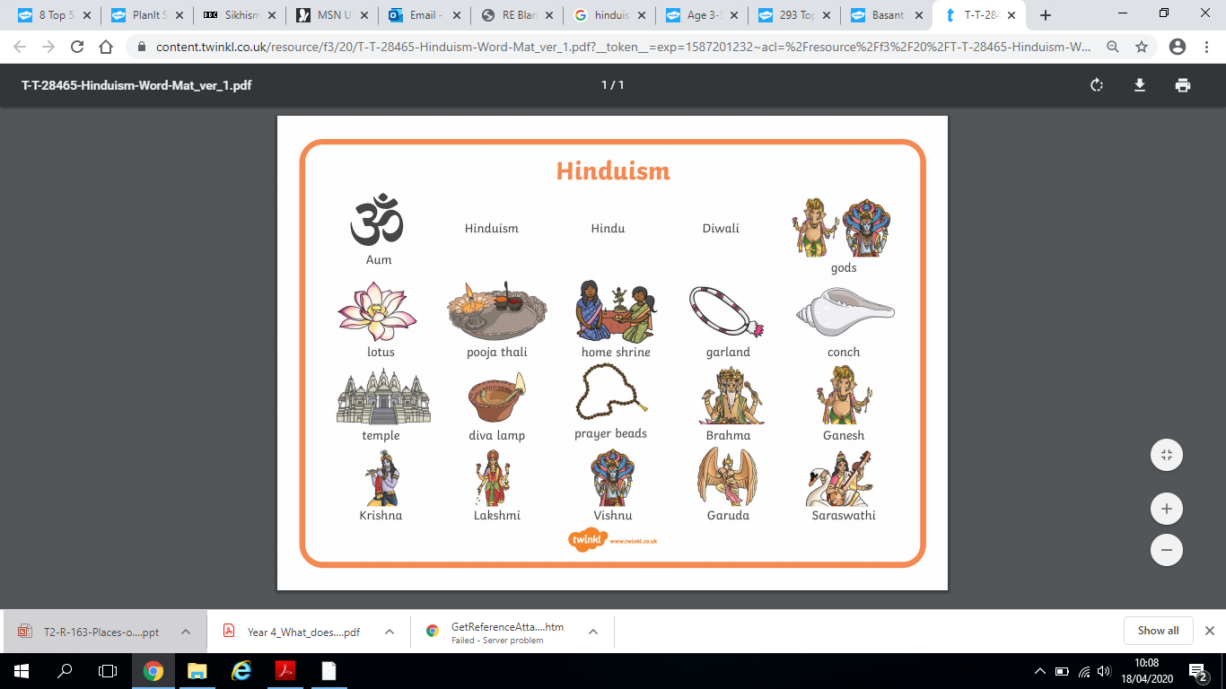

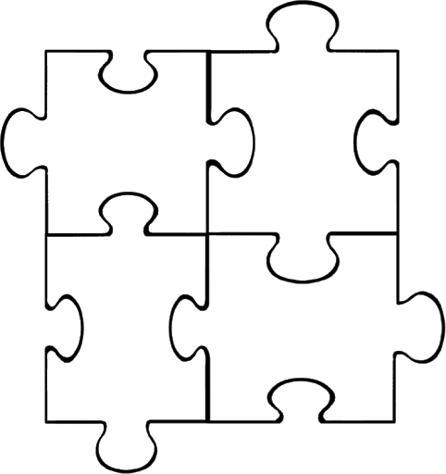ME

In this puzzle draw 4 things that are important to Simran or Vraj’s important things may include religion, hobbies, likes and dislikes, important aspects to their life. Use the information from the video to help you.



In this puzzle draw 4 things that are important to you. You might like to include your hobbies, interests or favourite event in the year. Once you have drawn your pictures you can then write about why they are important to you.

Simran or Vraj’s

