Home Learning – Maths
Timestables:
Children should practise their times tables daily.
Using the following link, you can create a ‘times tables’ practice sheet.

http://www.timestables.me.uk/printable-pdf-quiz-generator.htm

Children should practise their 3 and 4 times tables this week (including the ‘divide by’ questions). In class, we use sheets that are 40 questions long. You may want to print these out. Alternatively, you could write up questions or work through them verbally.

Monday:
Re-grouping
The following representations must be put into three groups. Please draw the dienes representation, and then match them with representations that are equal.
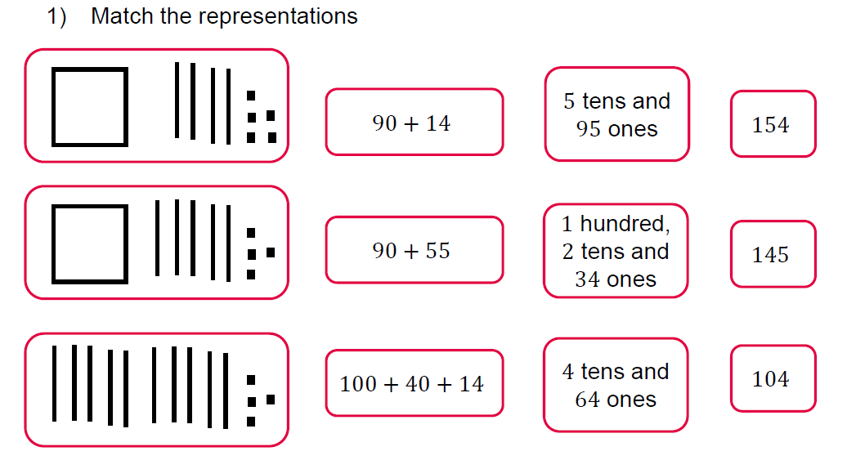
Extension:
Using the numbers above, can you think of any other ways you could partition them? There are many different possibilities. Can you come up with 5 new possibilities for each number?

Tuesday
Place Value Problem Solving:
Draw and write numbers using only 5 dienes blocks like the examples below. I would like to see the dienes representation, the numeral and the written words.
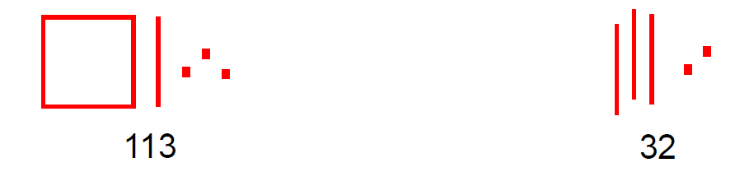
One hundred and thirteen thirty two
There are many different possibilities. Can you find at least 15?

Wednesday
Always, Sometimes, Never:
Write down the following statement in your book. Do you think it is always, sometimes or never true? Give me examples to prove your reasoning and write a full sentence answer to explain your reason.
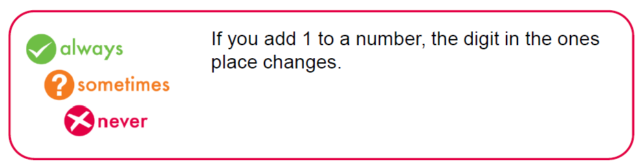
Now repeat this for the next statement.
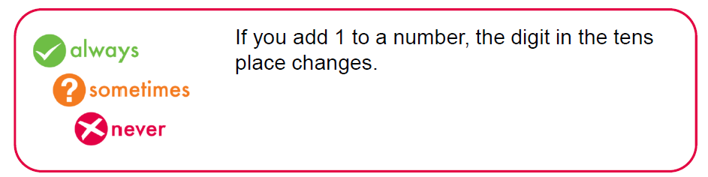
Now for this statement.
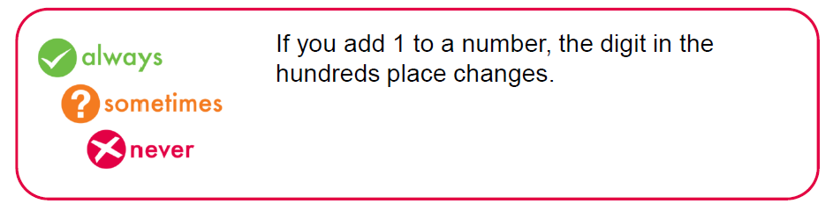
Always, Sometimes, Never Continued:
- Look back at your reasoning for the first statement. Does your rule work for these numbers?
43 189 465
If you find that your original reasoning was incorrect, you can now change it. If you were correct, well done!
- Look back at your reasoning for the second statement. Does your rule work for these numbers?
63 229 492
If you find that your original reasoning was incorrect, you can now change it. If you were correct, well done!
- Look back at your reasoning for the first statement. Does your rule work for these numbers?
27 189 699
If you find that your original reasoning was incorrect, you can now change it. If you were correct, well done!

Thursday
Comparing Using Inequalities:
Draw the following representations into your work book. You can then answer them by filling in the inequalities, the numbers or the counters.
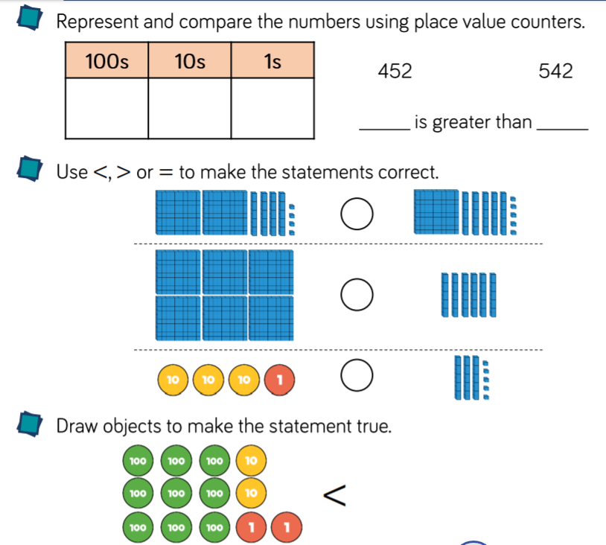

Continue onto next page!
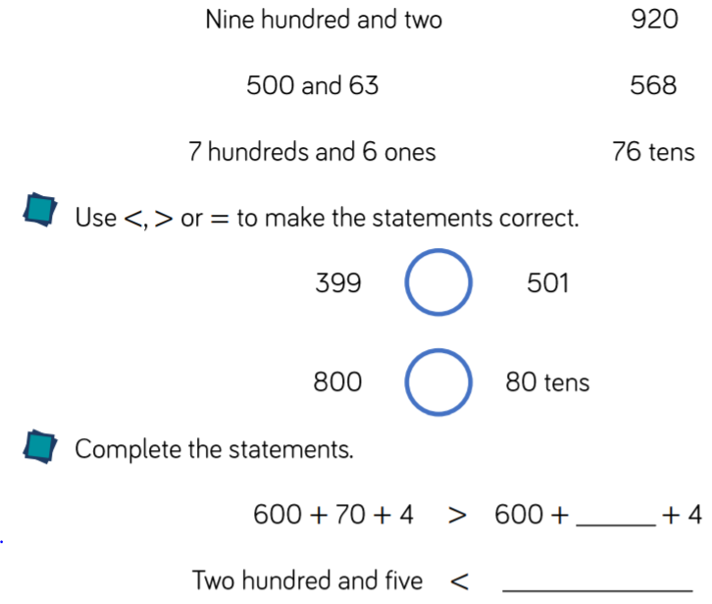

Friday:
Ordering 3-digit numbers:
Answer the questions below in your book using full sentences answers.
On which day of the week were the most hot dogs sold?
Answer: The most hot dogs were sold on ______.

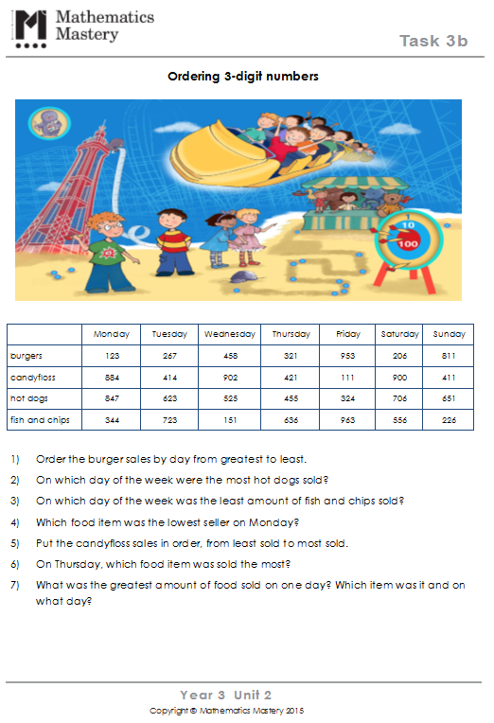

This one is a real challenge!
You must put the children in order of their number. A small clue for you, start with Harry and think about whose number you can work out from there!
