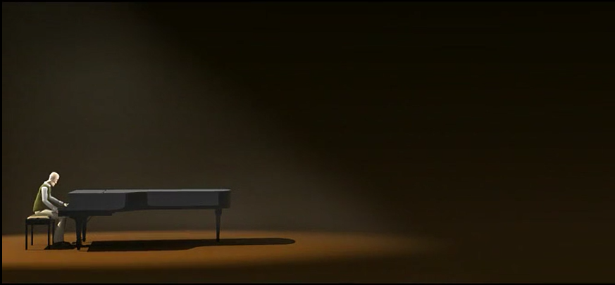
This is the opening shot of the short film The Piano.
Before watching the video, answer these questions in complete sentences into your book.
- Who do you think is the man?
- Where is he?
- Why do you think there is a spotlight on him? Why such long shadows?
- What questions do you have?

Now watch the film. https://vimeo.com/200936986

What questions and thoughts do you have now? Write down three thinking bubbles. (Yes, draw three thinking bubbles and write in your thoughts and/or questions. Yes, you are allowed more than three. No, you are not allowed less than three.)

