Alien Wildlife Safari destination
Today you are going to begin to write the first part of your travel brochure/tourist leaflet. You can type it; you can handwrite it; you can design it as one document with subheadings; you can organise it like an information leaflet (see the Dover Castle one); you can create a PowerPoint ...

To help you with your structure, I have listed suggestions for your chosen resort/hotel. You can write the individual parts of your brochure in any order you like – but if you find it hard to decide and to motivate yourself, follow my daily order.

Information you could include:
Wednesday  1 April | Front Cover:  . picture  . title of the hotel/resort  . slogan
Thursday  2 April | a bit of the history of Planet Garm and why it is an adventure of a lifetime  describe the features of Planet Garm and why it is the best place in the universe to go on a safari to watch alien life forms in their natural habitat
Friday  3 April | There is so much to do ...  Below this table, I put some suggestions of alien animals and some habitats.  Pick three alien animals, describe their natural habitat and describe the animals and what tourists might expect to see.  You may want to draw them first and then describe them. Take into consideration whether these animals come in herds or where to find them.
Monday  6 April | What equipment are you going to provide? Who are the instructors?  Are there health and safety restrictions or can anyone go?
Tuesday  7 April | Food and Drink – How does your hotel or the resort cater for its customers?  What specialities will be served in your hotel restaurant?
Wednesday  8 April | Accommodation  Where are the guests staying? What is the hotel like?  Where are the guests staying or how will they camp when they are on the safari out on the planet?
Thursday  9 April | Booking information
Thursday  9 April | How do you get to Planet Garm (travel information???)
Thursday  9 April | Customer feedback  Maybe two quotes from very happy customers about their experience
Friday  10 April | Proof-reading  Final pictures  Final improvements and re-writing if necessary

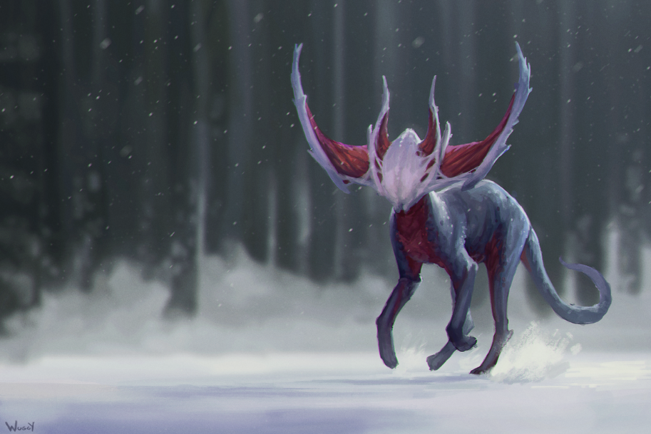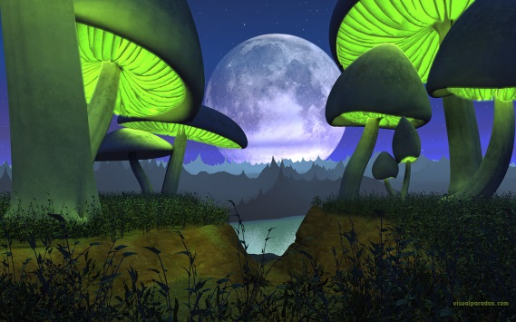
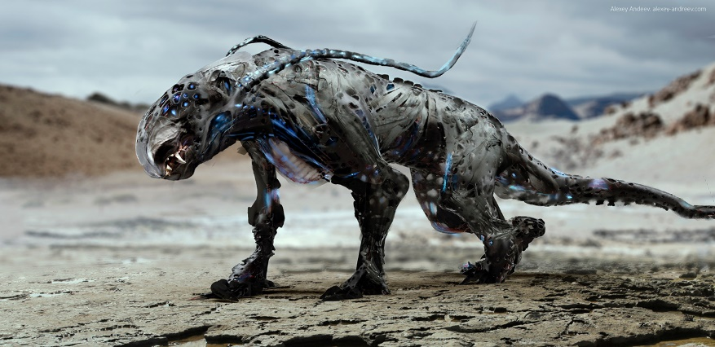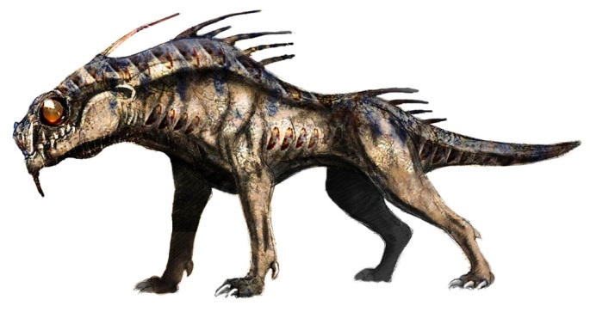
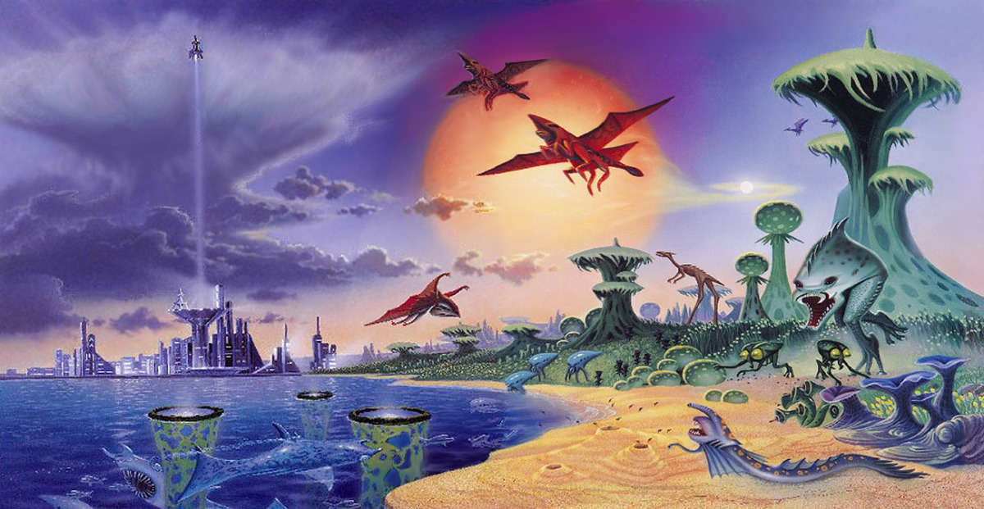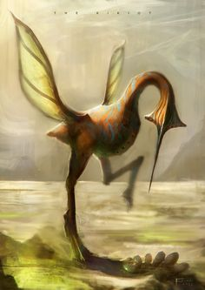

Websites that might help a bit with vocabulary and ideas:

https://www.naturalworldsafaris.com/

https://www.expertafrica.com/wildlife-safaris/africa

Be sensible when searching the Internet!

