Tuesday

Activity One: Inference – look at the picture closely and piece together clues.

First Flight

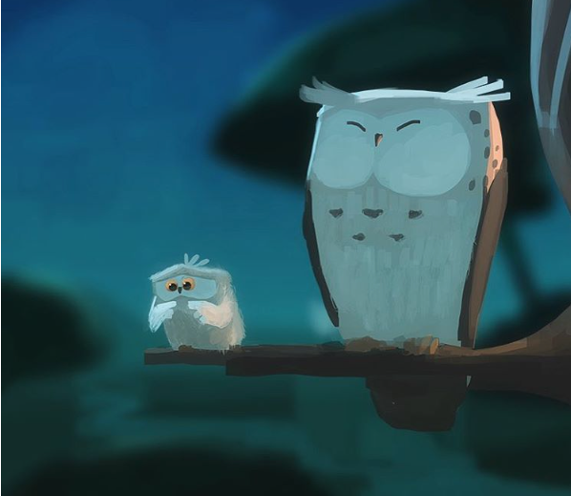

Please answer the following questions, explaining the evidence you find from the picture:
- How are the owls related?
- Which owl is about to take its first flight? How do you know?
- How does the young owl feel about flying?
- What might it be thinking? Add a thought bubble to the picture.
- Is the older owl worried?
- What advice might the older owl give to the younger one?

Activity Two: Write a short, descriptive story – at least one and a half pages.

