Home Learning – English task break down
Monday:
Read the Picture
Look at the following picture and then answer the questions using full sentences in your workbook. Please use full sentences (including capital letters and full stops).
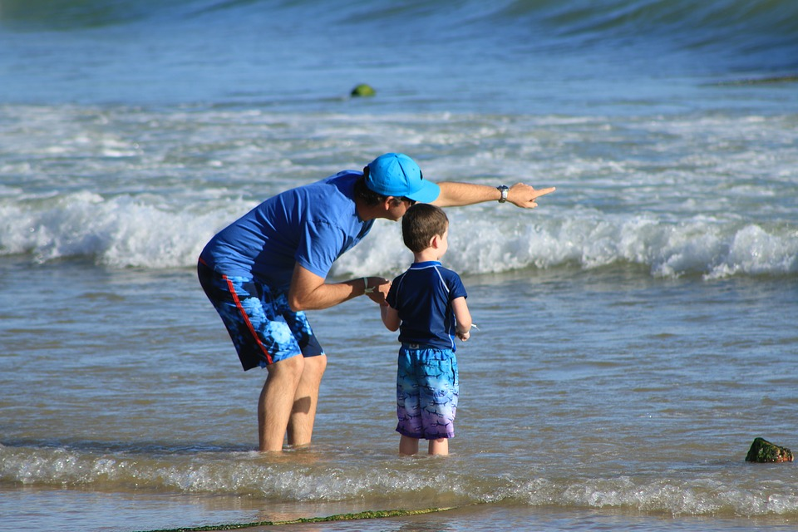
1. What adjective could you use to describe the waves?
2. In what setting was this picture taken?
3. Can you explain what is happening in this picture in less than 20 words?
4. What might the man be pointing at?
5. What do you think the man will say to the child?
6. What would be different about this picture if they were stood in a field?
7. If you could give this picture a title, what would you call it? Why?

Setting description:
Write me a setting description that matches the picture you have been looking at. Think about the mood and using vocabulary that matches. I want you to imagine you are in the picture. What can you see, hear, smell and feel?
Use the success criteria below to help you! Remember, everyone can achieve 1* objectives. 2** and 3*** are more difficult to include. Challenge yourself to do your best writing and remember to use your ‘think it, say it, write it, check it’ strategy.

Success Criteria:
1*
Joined up handwriting
Sentences make sense
Full stops and capital letters in the correct place.

2**
Exciting vocabulary (adjectives and verbs)
Extended noun phrases
Time adverbials

3***
Similes
Onomatopoeia

Tuesday:
Up-leveling sentences: independent
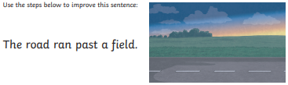
1. Re-write the sentence and add adjectives to create extended noun phrases.
2. Now rewrite the sentence again and add a fronted time adverbial. You should have some of these written in your workbook from last week. Remember, a fronted adverbial usually needs a comma after it.
3. Now rewrite your sentence and use one of the subordinating conjunctions from below to add a subordinate clause.
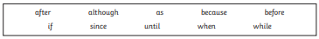
You should now have a complex sentence that includes extended noun phrases, a fronted time adverbial and a subordinate clause.

Now follow the steps above for the next sentences:
It travelled over a bridge.
1. Re-write, adding extended noun phrases.
2. Rewrite, adding a fronted time adverbial.
3. Rewrite, adding a subordinate clause.
The road disappeared into a tunnel.
1. Re-write, adding extended noun phrases.
2. Rewrite, adding a fronted time adverbial.
3. Rewrite, adding a subordinate clause.

Was/Were Sentences
Please write the following sentences into your workbook. You decide which word sounds correct in the sentence. Remember, we use ‘was’ for a singular subject (one thing/person on its own) and use were for a plural subject (a group of things/people).
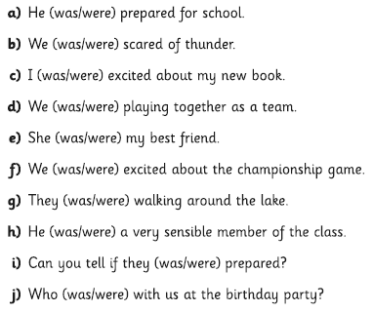
Now write 4 of your own sentences that use ‘was’ or ‘were’ correctly into your work books.

You will find answers below. You can check your own work and make any corrections you need to! Make sure they are all correctly punctuated.

Wednesday:
Changing Tenses: independent
Rewrite these sentences into your work books to turn them into past tense sentences.
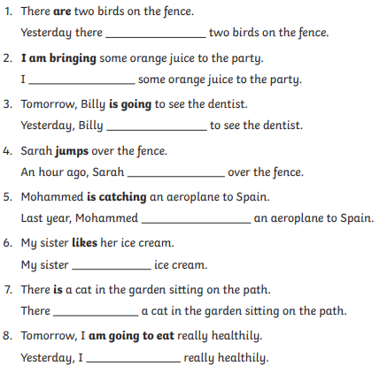

Inference sentences
Look at the sentence and answer the questions in your work books. You may think of more than one answer for each question. That is fine, you can write them both down!
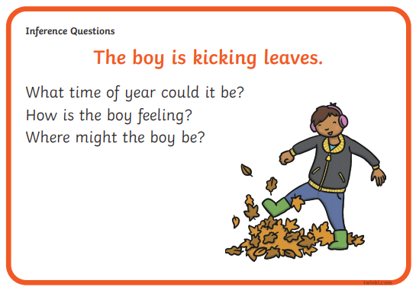

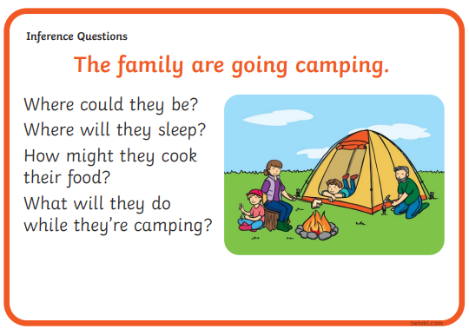

Thursday:
Changing Tenses: independent
Rewrite these sentences into your work books to turn them into present tense sentences.
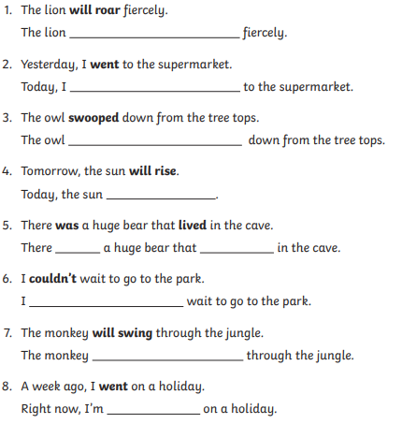

Comprehension: independent
First, read through the text. It is two pages long. I chose this text because now might be the perfect time to begin looking out for these birds in your own gardens!
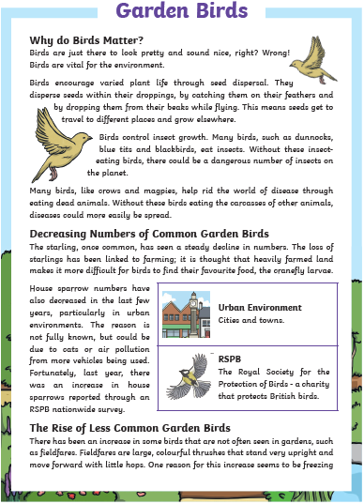
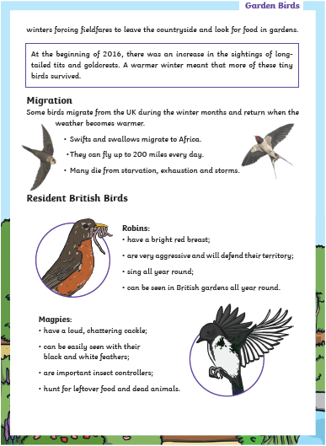
Work through the comprehension questions (following pages). Write your answers in your book in full sentences.
When you have finished, check that every sentence is punctuated correctly and then use the answers (at the end of the document) to check your work.
1. How do birds help with seed dispersal?
2. Why are insect eating birds important?
3. What is the benefit of birds eating the dead carcasses of dead animals?
4. Explain what problems have occurred due to heavily farmed land.
5. Why are there fewer house sparrows? Give one reason.
6. Describe how fieldfares move.
7. Name one bird whose numbers have increased. Explain why.
8. Why do some birds migrate, and where do they go?
9. Why might storms be a danger to migrating birds?
10. Are robins always cute and friendly?
11. Name one good thing that magpies do.

Friday:
Book review:
Write me a book review about something you have read this week! I have attached a picture to help you think about all of the information you will need to include.
There are 5 sections on the picture, so you might want to write your book review in 5 paragraphs. Remember to use an indent when you start a new paragraph!
You must remember full stops and capital letters. Try to keep your writing as neat as possible, and remember that in Year 3, ALL WRITING should be joined up!
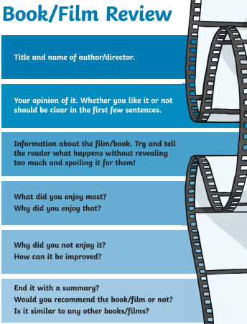
You might also like to add some illustrations or a picture of the cover.

Was/Were answers (Tuesday):
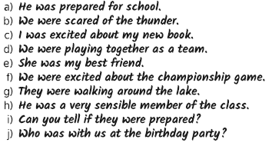

Comprehension question answers (Thursday):
