Home Learning Task Year 1

w/b 13/4/20 | Maths | English | Topic | Enjoy your reading book.  10+ minutes daily  Please keep a reading record.
Monday | Can you make your own number line to 50?  1 2 3 4 5 6 7 8 9 ………………………  Keep it safe as you will need it! | News writing – write your weekend news. What did you do on Easter Sunday? Did you get any eggs? How many have you eaten already!  Remember full stops and capital letters. | RE Activities
Tuesday | One more, one less  Look at the problem on the Maths Activites sheet.  Remember to give an reason for your answer.  For example –  Tom is right because ……. | Can you copy these sentences using the correct punctuation?  You might need capital letters, full stops and question marks.  - the boy went to the beach  - ben was very excited  - can i help you  - sam didn’t want to go | PE activities | Weekly Spellings  https://www.phonicsplay.co.uk/ is an excellent place for children to play phonic games. It is free for everyone at the moment.  Phase 3, 4 and 5.  Look at the Phase 3 sounds  j, v, w, x, y, z, zz, qu, ch, sh, th, ng  Vowel digraphs: ai, ee, igh, oa, oo, ar, or, ur, ow, oi, ear, air, ure, er  Choose one sound and write some words with that sound.  snow  bow
Wednesday | Look at the problem on the Maths Activites sheet.  Remember to explain your answer.  Can you draw a number track to represent these numbers?  25 – 1 =  32 + 1 =  45 – 1 = | Can you unscramble these sentences?  Remember full stops and capital letters might give you clues!  - likes chips. fish The cat and  - green? the Is Moon  - has The crown. Queen a  - is place. a London busy | Our new topic this term is The Enchanted Woodland.  Have you ever been for a walk in the woods?  Watch ‘Lets go for a Walk’  https://www.bbc.co.uk/iplayer/episode/m000g1w6/lets-go-for-a-walk-series-1-15-puddle-splashing-and-snakes-walk  Look at all the things they see.  If you can you might be able to go for a walk in a woods.
Thursday | Pick a number from 0-50.  Using the sheet, or recording in your book, write the number one more and one less.  How many can you do? | Think about a walk in the woods that you have done. Or think about the programme you watched yesterday.  What did you see?  What did you hear?  What did you smell?  Did you touch anything?  What did you do?  Fill in the sheet below or make your own. | Can you draw or paint or collage a picture of a woodland scene?  You might want to paint a winter scene where the trees are bare. Or a spring scene where you can see daffodils or bluebells.  Look at some of the woodland images to help you.  * top tip – use old magazines or newspapers for your collage.
Friday | Look at these numbers. Can you compare them?  Which one is greater than? Which one is less than?  For example -  - 16 and 21  16 is less than 21. I know that 21 is 5 greater than 21.  - 10 and 15  - 29 and 27  - 31 and 13  - 50 and 41  Use your number line to help you. | Write about a walk in the woods.  Use your ideas from yesterday.  For example -  One day I went for a walk in Clowes Woods. It was a lovely sunny day. As soon as I got out of the car I could hear the birds singing. I leapt out………… | If you can, try and make friends with a tree!  Choose a tree to befriend. Circle it with your arms, smell it, touch its bark and take a close look at its branches and leaves. Take rubbings of its bark, collect a few of its leaves and take a photograph of your tree.

see
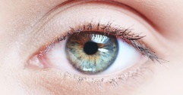

hear

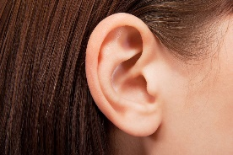
smell
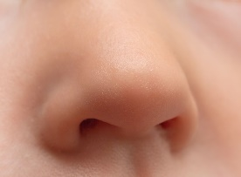

touch

